* digital regenerators eliminate the accumulation of noise
* digital transmission has lower overall system cost
* digital transmission can monitor the quality of a transmission channel while the channel is in service
* digital transmission can multiplex and switch any type of information that can be represented in digital form
* digital transmission allows networks to exploit the advantages in digital computer technology

(b)The Nyquist theorem is true for both copper wires and optical fibers. All of them are channels. In the case of optical fibers, this refers to the maximum frequency of the optical signal that can be transmitted through the fiber without distortion.

(c)there are two, one for uplink another for downlink.

(d)in circuit switching it makes a true physical connection there is no forward operation during the transmission.in message transmission, the message is completely received by the router(store) and then forward, however in packet switching, the data is split and received separately and assembled at last.

(e)the main difference is: each frame sent is individually acknowledged in acknowledged connectionless service, but there is no acknowledgement. In unacknowledged connectionless service.

In acknowledged connectionless service ,if a frame has not arrived within a specified time interval, it can be sent again.

The protocol using acknowledged connectionless service is more reliability sensitive

The protocol using unacknowledged connectionless service is more time sensitive

(f)Virtual circuits and datagrams are two different approaches to managing data transmission in computer networks.

Virtual circuits are used in circuit-switched networks while Datagrams are used in packet-switched networks.

virtual circuits provide a dedicated and reliable path for data transmission, while datagrams provide a faster and more flexible transmission method but with potential reliability issues.

(g)1-persistent CSMA: Listen whether the channel is free before transmitting. If busy, wait until i becomes free and then immediately start transmission.

p-persistent CSMA: Used with Slotted systems. If the hosts find the channel idle during the current slot, transmit with probability p. and defer until next slot with probability 1-p

(a)there are 6 necklaces, each necklace have 11 satellite. We can assume that a period is divided into 11 parts.the average interval for handoffs is 90/11 min.

(b)

(i)24000/2=12KHz

(ii)64 quantization level =>6 bits

24k samples/s \*6bits/sample =144 K bps

(iii)20s\*144Kbps =2.88Mbits

(c)

1. Wc=8000/2=4KHz
2. 2bits/sample \*8000samples=16Kbps
3. 16Kbps=4KHz \* wpsoffice ==>SNR=15

(d)cause the cellphone must disconnect from a base station first and then switch to another one. When the interval is a bit high sometimes the carrier will think that the user is offline and cutoff the call.

(e)the time spent in circuit switching Tc=s + kd + x/b

the time spent in packet switching is Tp=k\*d + (k-1)p/b+kd

When Tp<Tc ==> s>(k-1)p/b the packet switching has a power delay

1. (a)

(i)

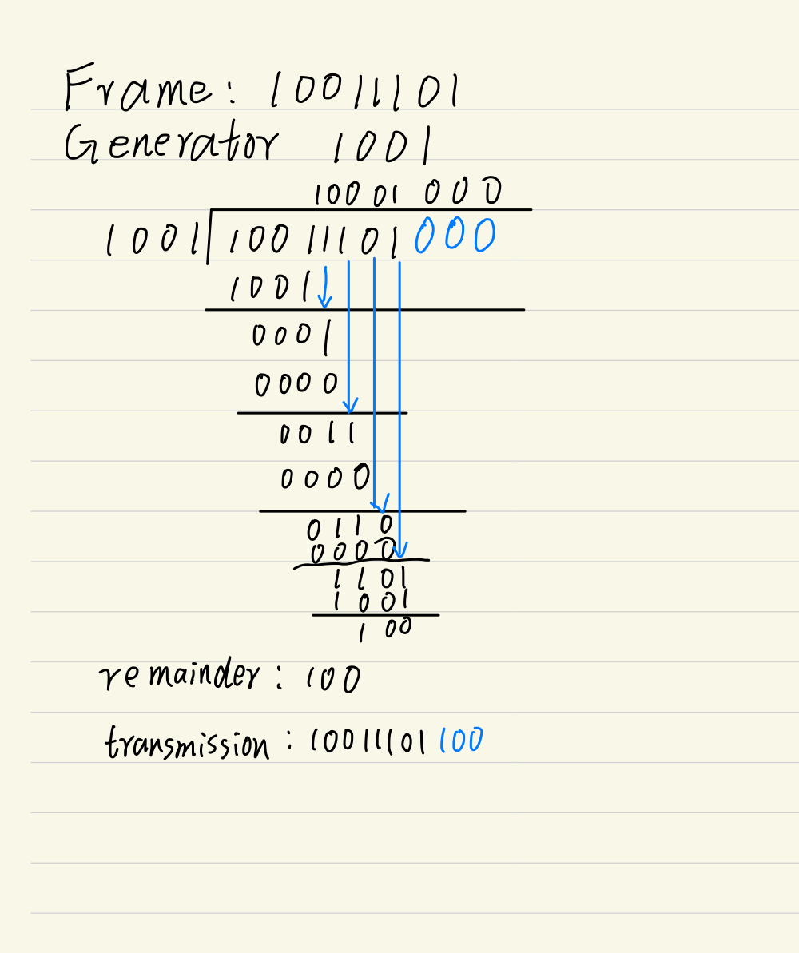

(ii)

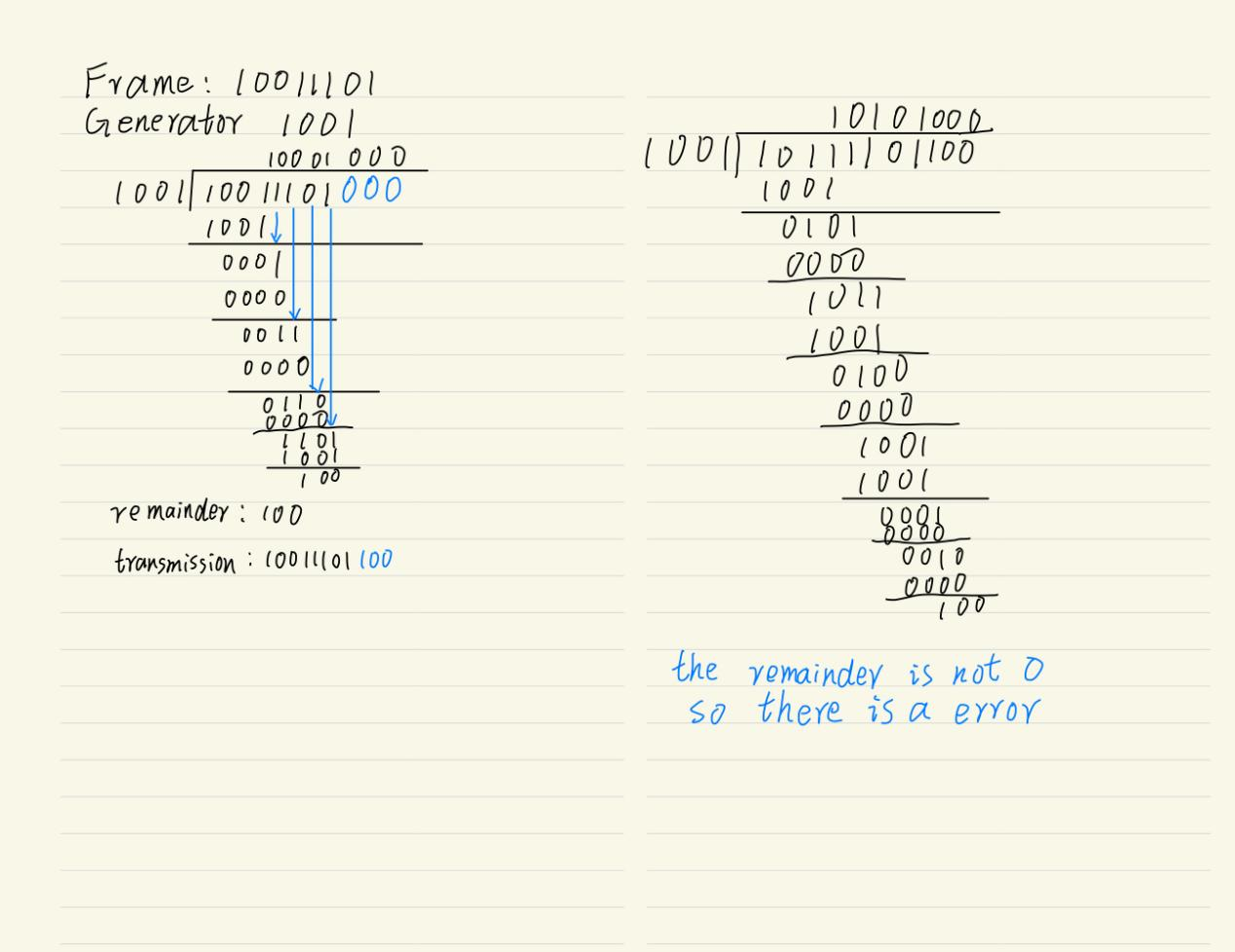

(b)

(i)

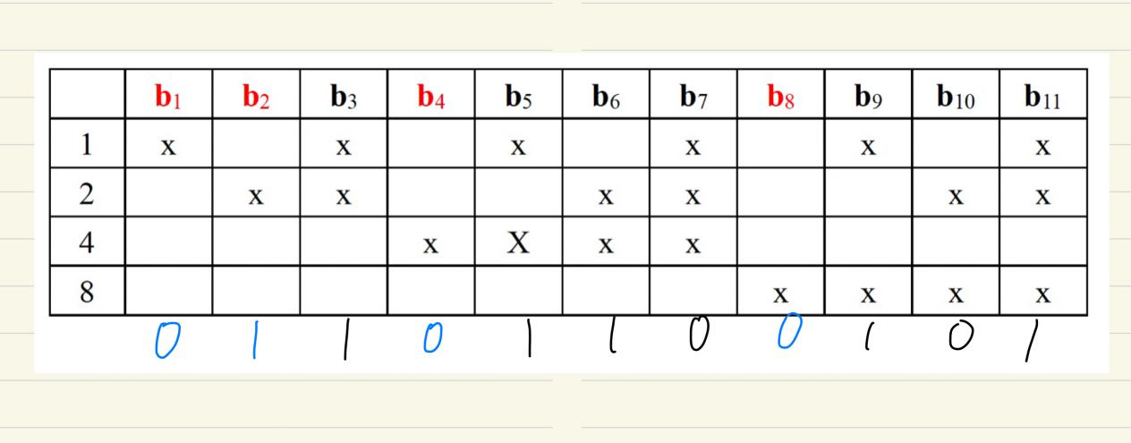

(ii)

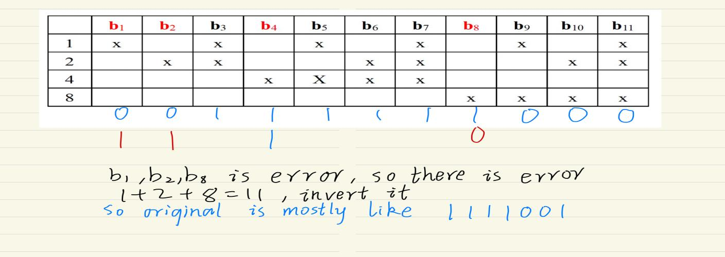

(c)connection-oriented acknowledged service provides reliable data transfer through the establishment of a dedicated connection, while connectionless acknowledged service does not require a dedicated connection and is typically used in real-time applications.

TCP provide connection-oriented acknowledged service it will establish a connection by ”3-times hand shaking” and release it by “4-times hand waving”,however the UDP who provide connectionless acknowledged service dosen’t have this procedure

1. (a)the delay of pure ALOHA is less cause it let users transmit whenever they have data to be sent, however the slotted ALOHA acquire users to send at the slot boundaries

(b)in the worst case, when a contention field is just over the station wants to transmit a frame but it can’t cause its contention bit is 0. So it must wait N\*d bit time first. Then in the next period, it wait N +(N-1)\*d to transmit(let it send at the last)

So the total time is N+(2N-1)\*d

(c)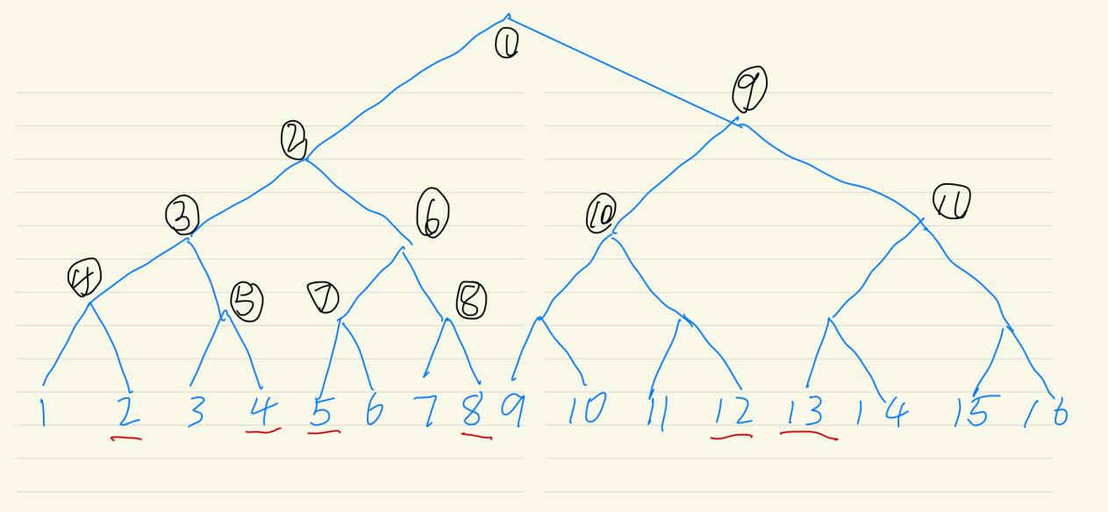

According to the figure shown above, we need 11 bit slots

(d)contention protocol has lower delay at low load but worse channel efficiency at high load

Collision-free protocol has higher delay at low load but better channel efficiency at high load

(e)because the IP datagram has no concept of “ports”.UDP add the feature of demultiplexing multiple processes using the ports.

(f)The minimum size of a TCP segment, including the TCP header, is 20 bytes

TCP segments of the minimum size are typically used for control messages, such as TCP SYN and ACK packets

(g)The byte stream sends data in a continuous sequence of bytes, while the message stream sends discrete messages with headers and payloads.